**LAB 11**

**11.1 Write a program which prompts the user to enter his/her name, and marks of 5 different subjects. The program should save the data in a structure and prints the roll no, student name, student subject individual marks and total marks.**

**SOURCE CODE**

#include<iostream>

using namespace std;

struct stdata

{

int rollno;

string name;

int subjectmarks[5];

};

int main ()

{

int total=0;

stdata stdata1;

cout<<"Enter name: "<<endl;

cin>>stdata1.name;

cout<<"Enter roll no: "<<endl;

cin>>stdata1.rollno;

cout<<"Enter marks of 5 subjects: "<<endl;

for(int i=0; i<=4; i++)

{

cin>>stdata1.subjectmarks[i];

total = total + stdata1.subjectmarks[i];

}

cout<<"The name of the student is: "<<stdata1.name<<endl;

cout<<"The roll no of the student is: "<<stdata1.rollno<<endl;

cout<<"The individual marks of the student is: "<<endl;

for(int j=0; j<=4; j++)

{

cout<<stdata1.subjectmarks[j]<<endl;

}

cout<<"The total marks of the student is: "<<total<<endl;

return 0;

}

**OUTPUT**

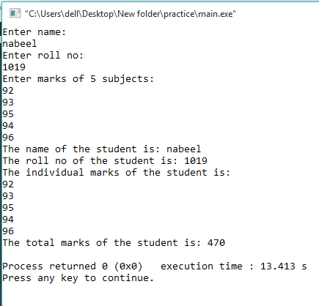

**11.2Using data structures, write a program which takes the input in an amount of seconds and converted into hours, minutes and seconds.**

**SOURCE CODE**

#include <iostream>

using namespace std;

int main()

{

int user = 0;

int hour = 0;

int min = 0;

int sec = 0;

cout << "Enter a time in seconds: ";

cin >> user;

hour = user/3600;

min = user/60;

sec = user;

cout<<"\nThe converted time is is: "<<hour<<" hours, "

<<min<<" minutes, and "<<sec<<" seconds!\n";

return 0;

}

**OUTPUT**

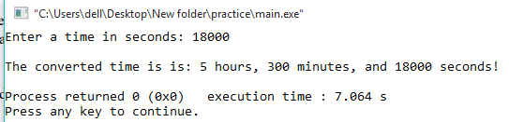

**11.3Write a Program to add, subtract, multiply and divide two complex numbers using structures**

**SOURCE CODE**

#include<iostream>

#include<math.h>

using namespace std;

struct complex

{

float real;

float imgaginary;

}c1,c2;

int main()

{

float a,b;

cout<<"First enter the real and then imaginary part of 1st complex number:";

cin>>c1.real>>c1.imgaginary;

cout<<"First enter the real and then imaginary part of 2nd complex number:";

cin>>c2.real>>c2.imgaginary;

cout<<"Calculating...\n"<<endl;

//For Div

a=(((c1.real)*(c2.real))+((c1.imgaginary)*(c2.imgaginary)))/(pow(c2.real,2)+pow(c2.imgaginary,2));

b=(((c2.real)*(c1.imgaginary))-((c1.real)*(c2.imgaginary)))/(pow(c2.real,2)+pow(c2.imgaginary,2));

cout<<"\nDivision: "<<a<<"+"<<b<<"i";

//For Sub

a=(c1.real)-(c2.real);

b=(c1.imgaginary)-(c2.imgaginary);

cout<<"\nSubtraction: "<<a<<"+"<<b<<"i";

//For Add

a=(c1.real)+(c2.real);

b=(c1.imgaginary)+(c2.imgaginary);

cout<<"\nAddition: "<<a<<"+"<<b<<"i";

//For Multi

a=((c1.real)*(c2.real))-((c1.imgaginary)*(c2.imgaginary));

b=((c1.real)*(c2.imgaginary))+((c2.real)*(c1.imgaginary));

cout<<"\nMultiplication: "<<a<<"+"<<b<<"i";

return 0;

}

**OUTPUT**

